Home page:

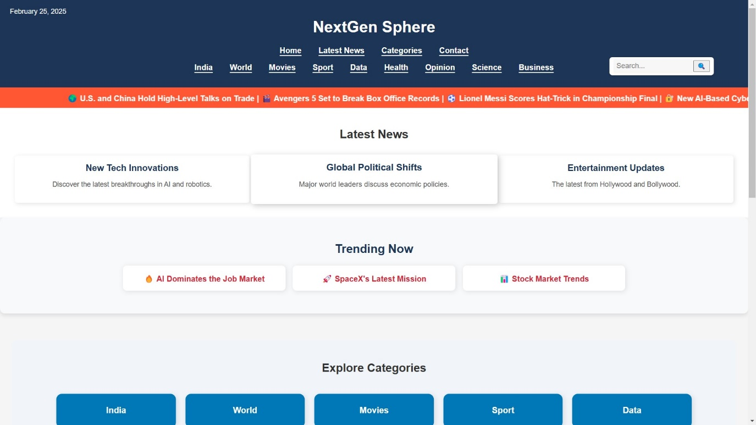

Home page with clean UI design

Marquee Effect:

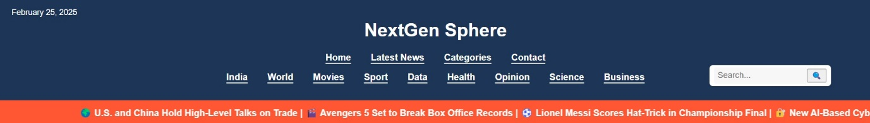

* Added a marquee effect using html and styled using css.
* The marquee effect will display some trending news in the header.
* The texts will loop from left to right of the panel.

Interactive Design:

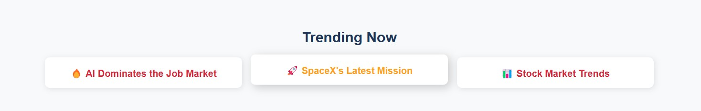

* Created interactive design for rich user experience!
* Styled with CSS.
* Added emoji to make it more attractive.

Categories Section:

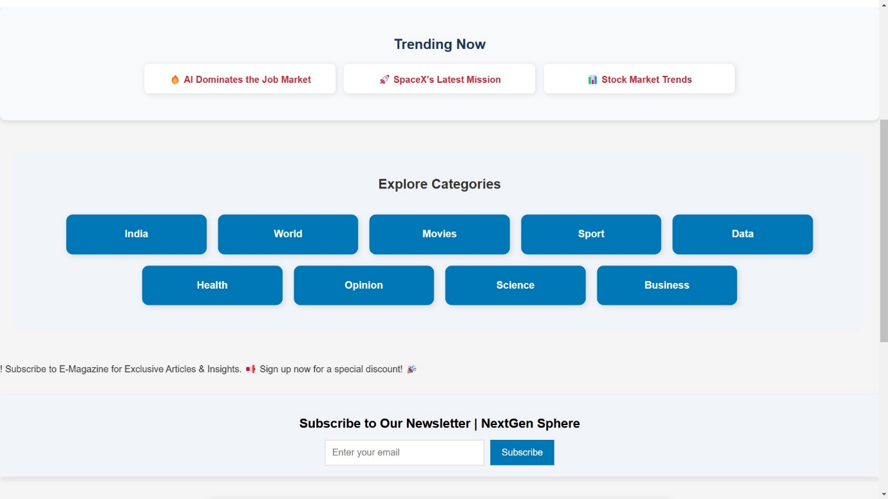

* Given a separate categories Section for each and every news categories.
* Linked with following html pages to load those contents once clicked
* Designed a "Hovering Button" to enhance user experience.

Comment Box:

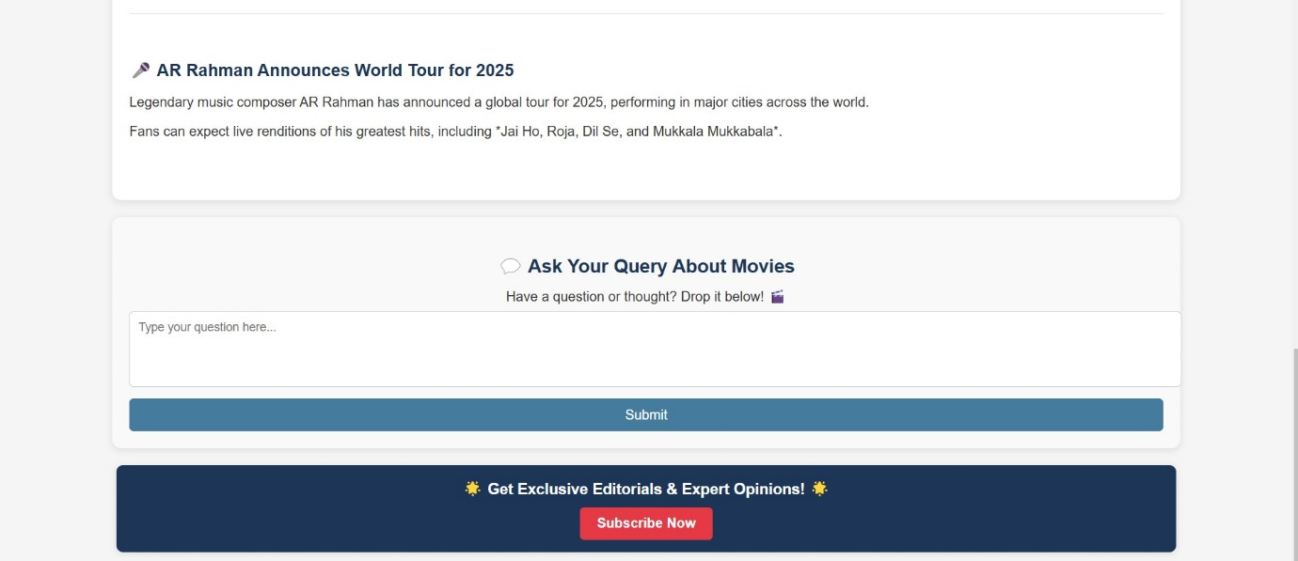

* Implemented a comment box on the homepage for user engagement.
* Enabled users to share their thoughts and feedback in real-time.
* Designed the comment section with a clean and user-friendly interface.
* Integrated a "Subscribe Now" feature for users to receive the latest news updates.
* Enhanced user engagement by allowing newsletter subscriptions.

Comment Section:

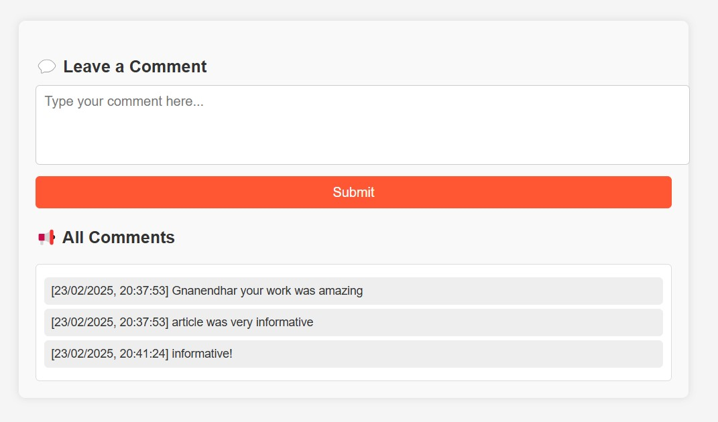

* Developed a backend comment system using JSON and Node.js for real-time updates.
* Enabled dynamic comment submission and instant updates without page refresh.
* Comments will update with time-stamps.

News Categories:

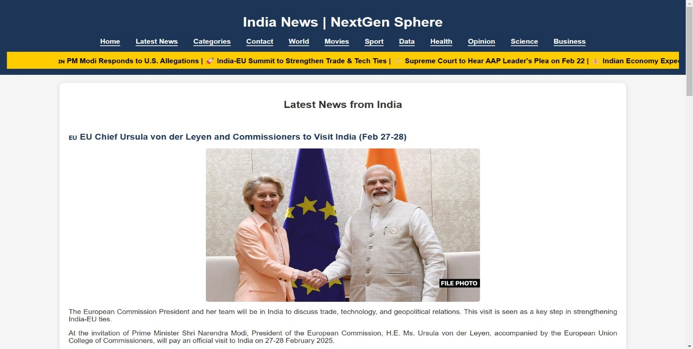

* Created dedicated pages for each category to enhance content organization.
* Improved navigation by allowing users to explore specific topics easily.
* Added marque effect in all pages!

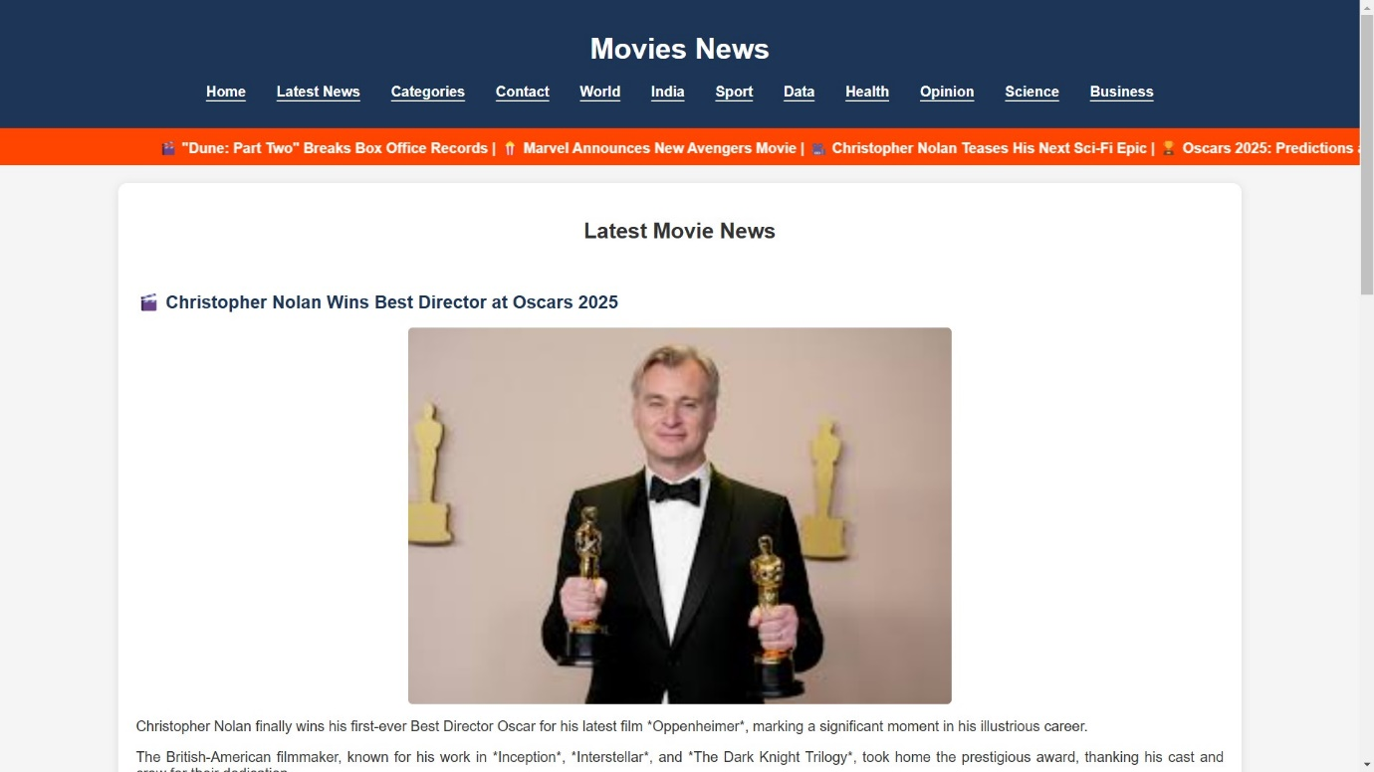

* Added images to the articles.

Server:

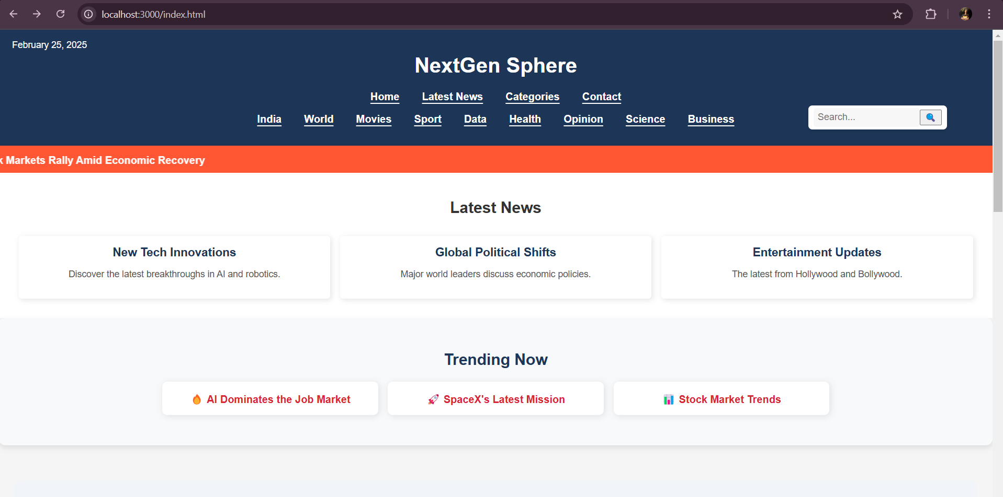

* Set up a Node.js server using server.js to serve the website.
* Enabled real-time comment updates and dynamic content handling.

Playable Videos:

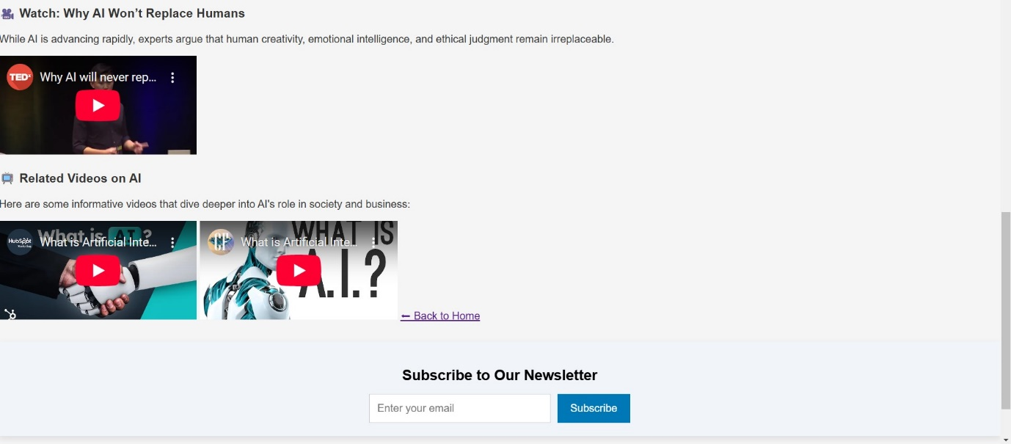

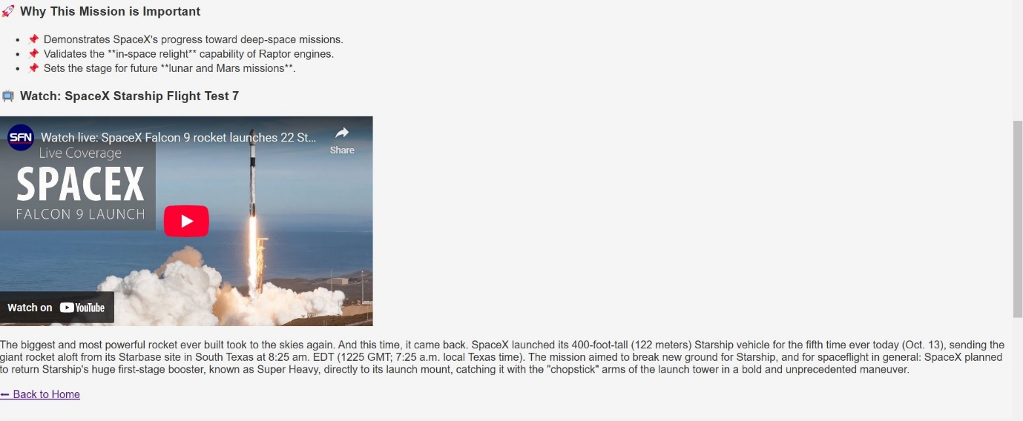

* Integrated multimedia support with embedded YouTube videos.
* Enabled playable YouTube videos for an interactive user experience.

Pop-ups:

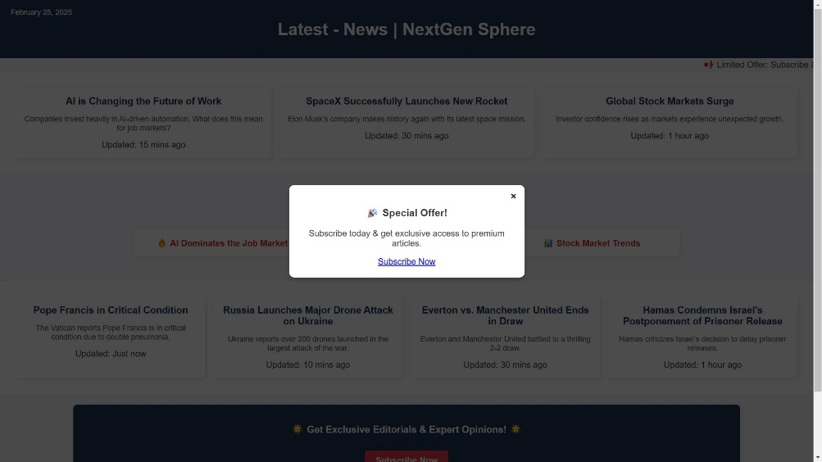

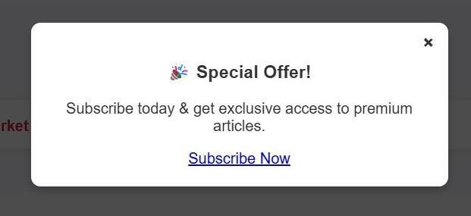

* Designed and implemented popup ads using HTML and CSS.
* Enhanced user engagement with visually appealing ad popups.

Latest News Update Page:

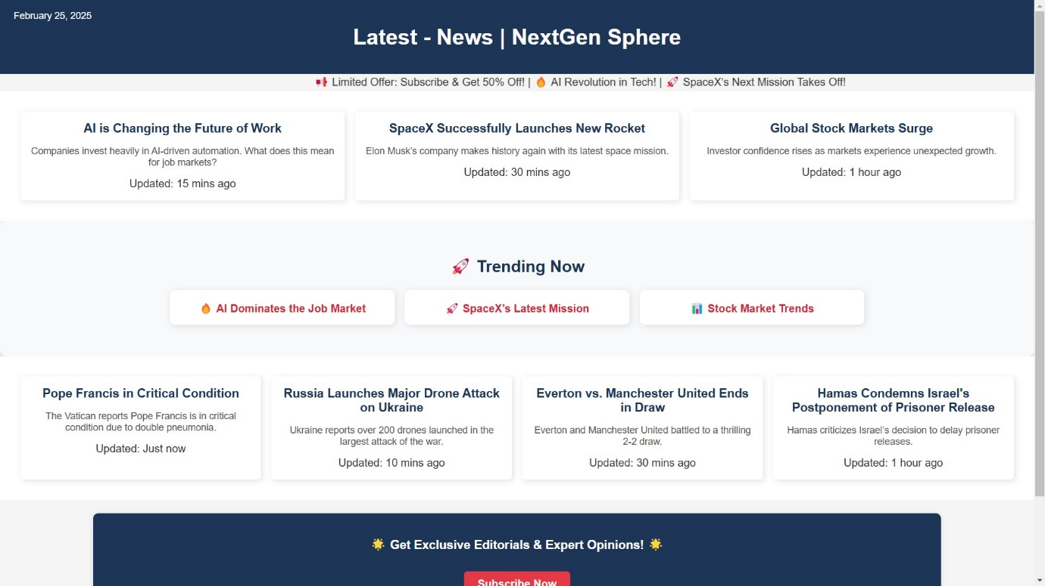

* Created a dedicated page for the latest hot news.
* Integrated articles with relevant images for better readability.
* Ensured a visually appealing and user-friendly layout.

Subscription:

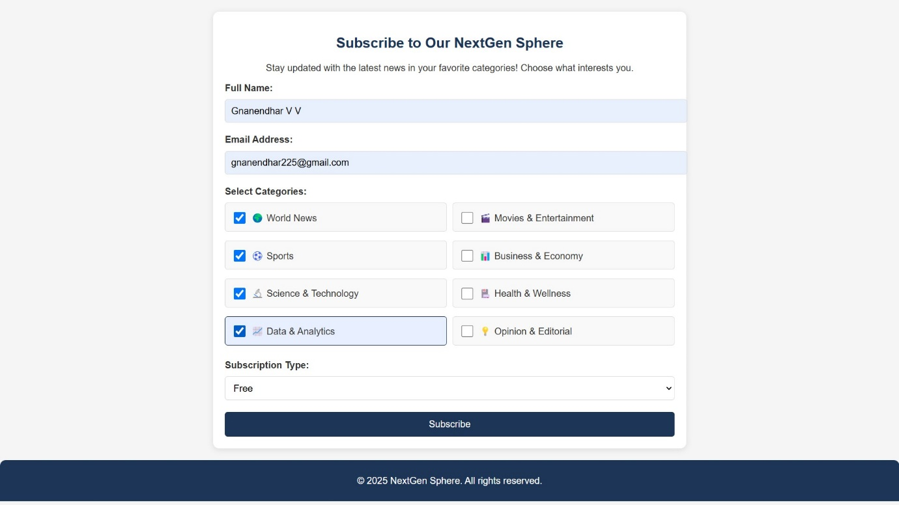

* Users can subscribe by entering their name, email, and selecting preferred news categories.
* Options available for different subscription types like Free and Premium.
* Simple and clean UI with an easy-to-use "Subscribe" button.

Contact Us Section:

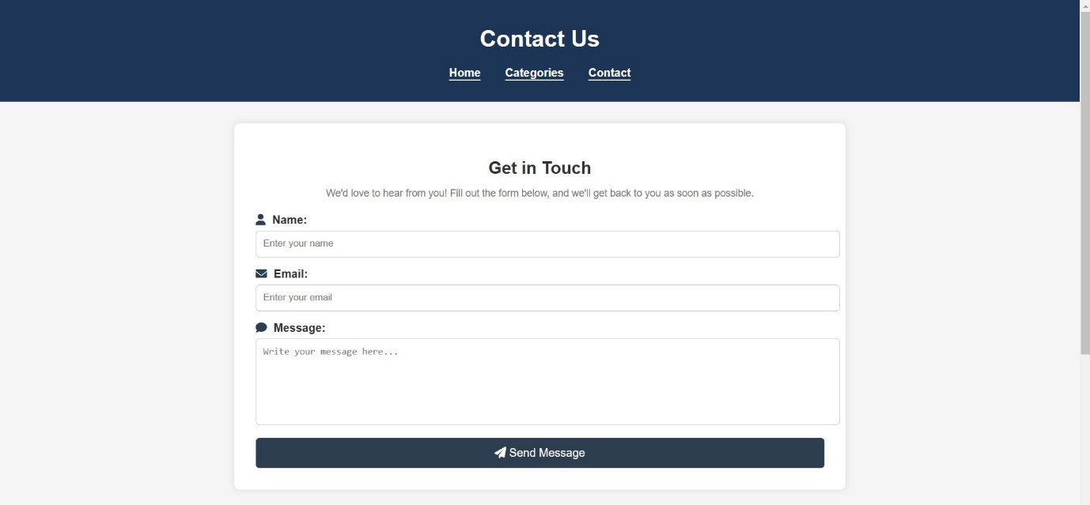

* Implemented a **Contact Us** form that collects the user's **name, email, and message**.
* On submission, the data is captured and stored for further processing.
* A clean UI and easy-to-use form fields.

Headers and footers:

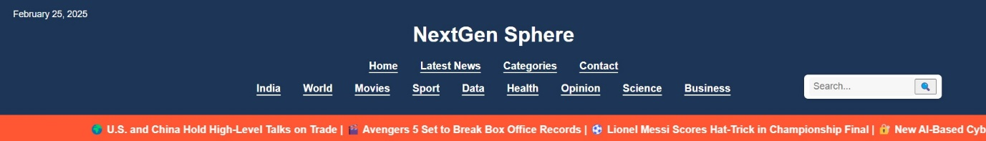

* Implemented **consistent headers and footers** across all pages for a uniform look.
* Enhanced **user experience**

